Business Template

household appliances store
Gulem Toktamys

Contents
1 Business Description 3
1.1 Business background 3
1.2 Problems. Current Situation 3
1.3 The benefits of implementing a database. Project Vision 3
2 Model description 3
2.1 Definitions & Acronyms 3
2.2 Logical Scheme 3
2.3 Objects 3

Business Description

Business background
A household appliances store sells a variety of products such as refrigerators, washing machines, ovens, microwaves, vacuum cleaners, and other electronic appliances. The store serves both walk-in and online customers and maintains relationships with multiple suppliers that provide the products. Employees handle customer orders, update inventory, and manage sales.

Problems. Current Situation
Currently, the store tracks products, customers, orders, and supplier information using separate Excel files. This creates several problems:
- Data duplication and inconsistencies
- Difficulty tracking stock levels
- No unified view of customer order history
- Manual errors when updating inventory
- Difficult to track which suppliers provide which products
- Reports are time-consuming and error-prone

the Benefits of implementing a database. Project Vision
Implementing a proper relational database will allow the store to:
- Maintain accurate inventory levels
- Track all orders and customer history
- Record all employees involved in handling orders
- Maintain clear information about multiple suppliers
- Support many-to-many relationships (Products ↔ Suppliers, Orders ↔ Products)
- Generate accurate reports and analytics (sales, stock, supplier efficiency)
- Reduce manual errors and improve business efficiency
The vision is to create an organized, scalable, normalized (3NF) database that supports all key business processes.

Model description

Definitions & Acronyms
• PK – Primary Key
• FK – Foreign Key
• M:N – Many-to-Many relationship
• 1:N – One-to-Many relationship
• Order – A purchase made by a customer
• Supplier – Organization providing products

Logical Scheme
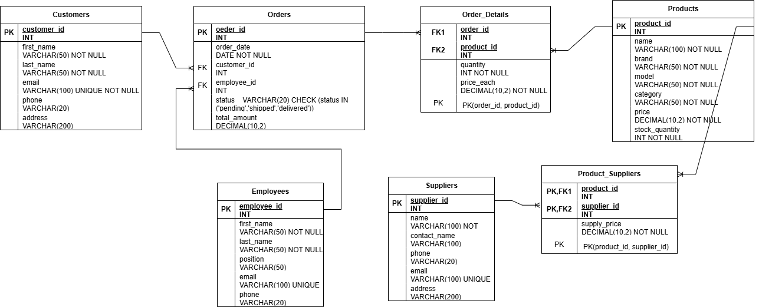

Objects

Table Description
Stores information about household appliances available in the store.

Table Name | Field name | Field Description | Data Type
Products | product_id | Unique product ID (PK) | Int
Products | name | Product name | VARCHAR(100)
 | brand
  Brand of appliance
  VARCHAR(50)
 | model
  Model identifier
  VARCHAR(50)
 | category
  Product category
  VARCHAR(50)
 | price
  Retail price
  DECIMAL(10,2)
 |  |  | INT
  stock_quantity
  Available units

Comments on table relationships

Example with data

product_id | name | brand | model
1 | Refrigerator | Samsung
  RT35
category | price | stock_quantity
Large Appliance | 1200.00 | 15

Table Description
Stores customer details.

Table Name | Field name | Field Description | Data Type
Customers | customer_id | Unique customer ID (PK) | Int
Customers | first_name |  | VARCHAR(50)
  Customer first name
 | last_name
  Customer last name
  VARCHAR(50)
 | email
  Customer email
  VARCHAR(100)
 | phone
  Phone number
  VARCHAR(20)
 | address |  | VARCHAR(200)
  Address

Comments on table relationships

Example with data

customer_id | first_name | last_name | email
1 | Aidos | Bekov
  aidos@mail.com
phone | address
77010020030 | Astana abai street 100

Table Description
Stores employee information.

Table Name | Field name | Field Description | Data Type
Employees | employee_id | Unique employee ID (PK) | Int
Employees | first_name |  | VARCHAR(50)
  Employee first name
 | last_name
  Employee last name
  VARCHAR(50)
 | email
  Employee email
  VARCHAR(100)
 | phone
  Phone number
  VARCHAR(20)
 | position |  | VARCHAR(50)
  Job role

Comments on table relationships

Example with data

employee_id | first_name | last_name | email
1 | Dana | Serikova
  dana@store.com
phone | position
77050000000 | Sales Manager

Table Description
Stores customer orders.

Table Name | Field name | Field Description | Data Type
Orders | order_id |  | Int
  Order ID (PK)
Orders | order_date |  | DATE
  Date of order
 | customer_id
  FK → Customers
  INT
 | employee_id
  FK → Employees
  INT
 | status
  Order status
  VARCHAR(20)
 |  |  | DECIMAL(10,2)
  total_amount
  Total order price

Comments on table relationships

Example with data

order_id | order_date | customer_id | employee_id
1 |  | 1
  2025-02-15
  1
status | total_amount
delivered
  1850.00

Table Description
Stores products included in each order.

Table Name | Field name | Field Description | Data Type
Order_Details | order_id |  | Int
  FK → Orders
Order_Details | product_id |  | INT
  FK → Products
 | quantity
  Units ordered
  INT
 | price_each
  Product price at order time
  DECIMAL(10,2)

Comments on table relationships

Example with data

order_id | product_id | quantity | price_each
1 |  | 1
  1
  1200.00

Table Description
Stores supplier information.

Table Name | Field name | Field Description | Data Type
Suppliers | supplier_id |  | Int
  Unique supplier ID (PK)
Suppliers | name
  Supplier name
  VARCHAR(100)
  contact_name
  Contact person
  VARCHAR(100)
 | phone
  Phone number
  VARCHAR(20)
 | email
  Email
  VARCHAR(100)
 | address |  | VARCHAR(200)
  Address

Comments on table relationships

Example with data

supplier_id | name |  | phone
  contact_name
1
  Global Electronics
  Alex Kim
  77015556677
email | address
sales@globelec.com
  Seoul jiang nan, oli street 105

Table Description
Indicates which supplier provides which products.

Table Name | Field name | Field Description | Data Type
Product_Suppliers | product_id |  | Int
  FK → Products
Product_Suppliers |  |  | INT
  supplier_id
  FK → Suppliers
  supply_price
  Wholesale price
  DECIMAL(10,2)

Comments on table relationships

Example with data

product_id | supplier_id
  supply_price
1
  1
  900.00

